PROJECT REPORT TEMPLATE

INTRODUCTION

OVERVIEW

Create and manage vehicle records to optimize the usage of your trucks and trailers that carry inventories to stores. To track the vehicle that carry goods out of a warehouse, assign them to that warehouse.

PURPOSE

Vehicle management is an appllication where a customer details are stored inorder to choose cars, bikes and commercial vehicles for travel with in the city. The data which is stored here is further used to remain them if any offers are provided during the seasons and any updates regarding vehicles are send to them in the form of message and mails.

EMPATHY MAP 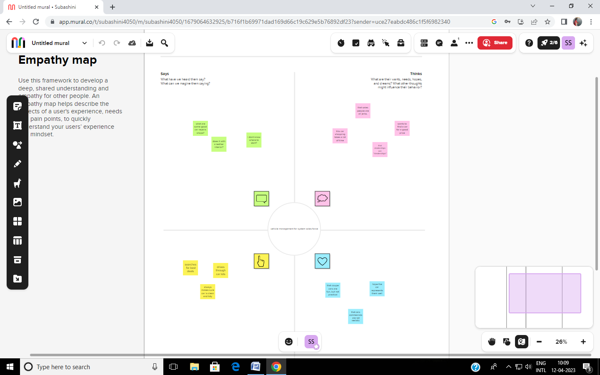

IDEATION & BRAINSTORMING MAP

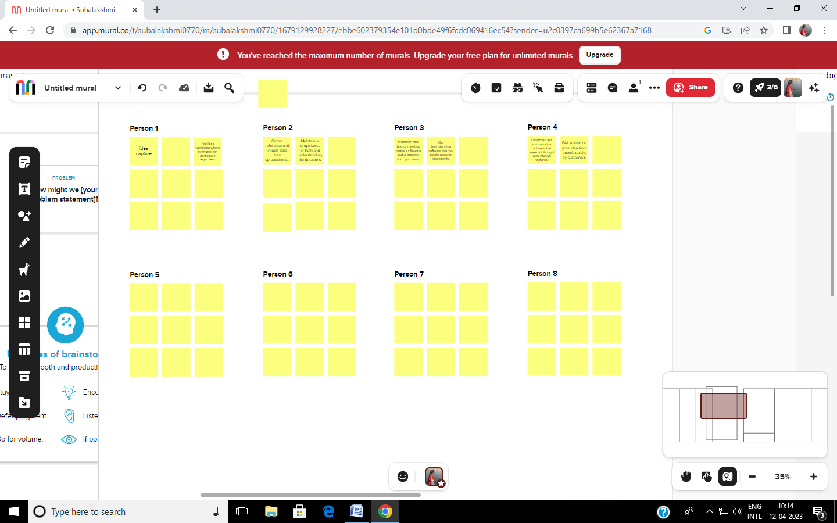

RESULT

DATA MODEL

|  |  |
| --- | --- |
| OBJECT NAME | FIELDS IN THE OBJECT |
| OBJ 1 | |  |  | | --- | --- | | FIELD LABLE | DATA TYPE | | Vehicle | number | | Car | Text | |
| OBJ 2 | |  |  | | --- | --- | | FIELD LABLE | DATA TYPE | | Vehicle | Number | | car | text | |

ACTIVITY & SCREENSHOR

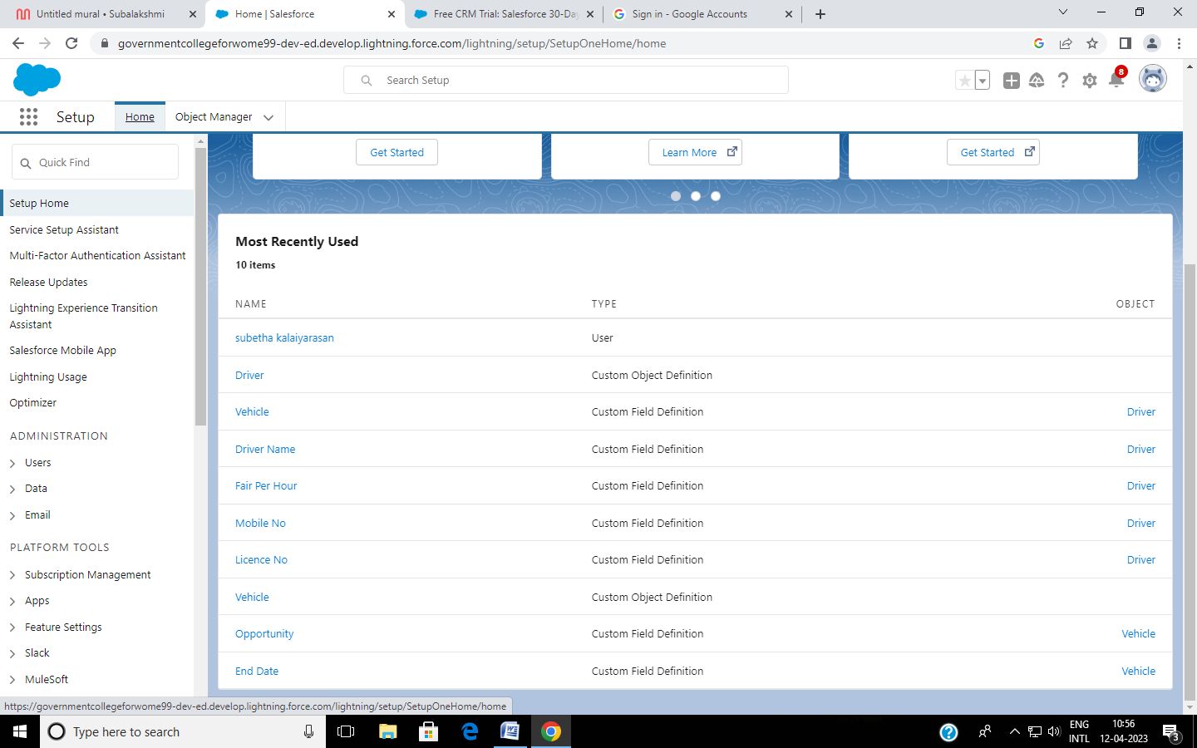

ADVANTAGES & DISADVANTAGES

Vehicle management features – advantages – benefits

Advantages – vehicle management. Duplication of the vehicle data is avoided. As vehicle number is already stored in the master therefore human mistakes can be avoided. Timely alerts ensure that penalties are avoided.

Active tracking based fleet management requires monthly subscription charges and data usage charges.

GPS Device used in fleet management is power hungry which drains battery faster.

APPLICATION

The vehicle management system is an application for the automotive industry. It support in the area of sales and service the business processes that you require as vehicles importer when dealing with your original equipment manufacturers and your dealers in new and used vehicle sales.

CONCLUSION

The main purpose for developing this project can helps to manage the customer details driver details etc.

FUTURE SCOPE

By component: Solutions service

deployment type: on-premises cloud